DEVELOPING A TRAVEL AGENCY WEBSITE USING HTML AND

CSS

A PROJECT REPORT

*Submitted by*

Ishan Elayoden

*in partial fulfilment for the award of the degree* *of*

# BACHELOR OF TECHNOLOGY(CSE)



Lovely Professional University, Punjab

Registration no: 12401140

NOV 2024

INDEX PAGE: -

TABLE OF CONTENTS

|  |  |  |
| --- | --- | --- |
| CHAPTER NO. | CHAPTER NAME | PAGE NO. |
|  | Title Page | 1 |
|  | Index Page | 2 |
|  | Introduction to project | 3 |
|  | Technology Used | 3 |
|  | Workflow | 3 |
|  | Working on the project | 4 |
|  | Code snippets of the project | 5 - 25 |
|  | Output Screenshots | 25 -30 |
|  | Conclusion | 30 |
|  | References | 31 |

INTRODUCTION:

Creating a comprehensive travel booking website using HTML and CSS is an excellent way to start building user-friendly web interfaces! Below, I'll walk you through the basic structure for a booking page. This will include an HTML form to collect customer details and contact information, styled with CSS for a clean, professional look. The website will offer services like flight ticketing and visa applications, ensuring a seamless experience for travelers. This will also help direct you to the visa portal of various countries.

* HTML Form: The form collects basic customer details, like name, passport number and other necessary details.

* CSS Styling: CSS provides a clean look with padding, background colour, rounded corners, and hover effects for buttons.

TECHNOLOGY USED:

Building a Travel Agency with HTML and CSS forms the front-end foundation. Here’s an overview of the technologies commonly involved:

1. HTML (Hypertext Markup Language)
   * Purpose: Structures the content of the Travel Agency website.
   * Usage: Creates the form for user to input their details which can be used for ticket booking and also a table which displays the visa charges of various countries is present,this webpage can also be used to get redirected to official visa portals of various countries.
2. CSS (Cascading Style Sheets)
   * Purpose: Styles the website to make it visually appealing and user-friendly.
   * Usage: Designs the layout, colours, fonts, and adds interactivity (like hover effects on buttons)

WORKFLOW:

The workflow of the Easy Travels website involves a sequence of interactions between the user interface (UI) and the backend. Here’s a breakdown of how the workflow typically proceeds, from when a user accesses the site to making a booking or inquiry:

1. User Accesses the Website: -

○ Front-End (HTML & CSS): The user opens the Easy Travels website, which loads the HTML and CSS files to display the travel services and information.

1. User Can Fills Out the join Form: -
   * Front-End (HTML): The user enters their information in the form fields, selecting the services they are interested in, such as flight ticketing or visa services, and their contact details.
   * CSS: Provides a polished, accessible design for easy data input.

3.User Navigates to Services:

* + Front-End (HTML): The user can navigate through the services section to get detailed information about ticketing and visa services.
  + CSS: Enhances the visual presentation of service details and user experience.

4. User Submits Booking Form:

* Front-End (HTML): The user fills out the booking form with personal details, travel details, passport information, and contact details.
* CSS: Ensures a user-friendly interface for form submission

WORKING ON PROJECT:

○ A Travel Agency website project is a great way to apply HTML and CSS skills, and it can be expanded to include JavaScript for interactivity and server side features if needed.

Here are some ideas to enhance the project:

1. Responsive Design: Make the form adapt to different screen sizes, so it looks good on mobile and desktop.
2. Interactive Features: Consider using JavaScript to validate form inputs or create a dynamic games picker.
3. Styling Options: You could try different CSS styles, such as adding animations or

hover effects to buttons.

Code snippets of the project:

Styles.css

<style>

body { background-color:white;

} ul { list-style-type: none; margin: 0; padding: 0; overflow: hidden; background-color: #38444d; border-radius: 10px;

}

li {

float: left;

}

li a, .dropbtn { display: inline-block; color: white; text-align: center; padding: 14px 16px; text-decoration: none;

}

li a:hover, .dropdown:hover .dropbtn { background-color: red;

}

li.dropdown { display: inline-block; }

.dropdown-content { display: none; position: absolute; background-color: #f9f9f9; min-width: 160px; box-shadow: 0px 8px 16px 0px rgba(0,0,0,0.2); z-index: 1;

}

.dropdown-content a { color: black; padding: 12px 16px; text-decoration: none; display: block; text-align: left;

}

.dropdown-content a:hover {background-color: #f1f1f1;}

.dropdown:hover .dropdown-content { display: block;

}

img { display: block; margin-left: auto; margin-right: auto;

}

body {

background-image: url("https://images.unsplash.com/photo-

1689915638536-

4b026a60342d?q=80&w=1938&auto=format&fit=crop&ixlib=rb-

4.0.3&ixid=M3wxMjA3fDB8MHxwaG90by1wYWdlfHx8fGVufDB8fHx8fA%3D%

3D");

}

p. { font-family: Arial, Helvetica, sans-serif;

}

footer { background-color: #38444d; color: white; text-align: center; padding: 10px 0; width: 100%; bottom: 0;

}

.footer-links a { color: white; text-decoration: none; margin: 0 15px;

}

.footer-links a:hover { text-decoration: underline;

}

label{ display: block; margin-bottom: 10px;

}od

.btn {

background-color: #38444d;

border: none; color: white; padding: 12px 16px; font-size: 16px; cursor: pointer;

}

.btn:hover { background-color: red;

}

</style>

Home page;

<!DOCTYPE html>

<html>

<head>

<link rel="stylesheet" href="stylesforproject.css">

<style>

  table {

  font-family: arial, sans-serif;

  border-collapse: collapse;

  width: 70%;

}

td, th {

  border: 1px solid #dddddd;

  text-align: left;

  padding: 8px;

}

tr:nth-child(even) {

  background-color: #dddddd;

}

    input[type="text"], input[type=email], input[type="password"], select,textarea{

     width:40%;

     padding: 10px;

     border: none;

     border-radius: 5px;

    }

    input[type="submit"], input[type="reset"]{

        background-color: rgba(225, 83, 18, 0.746);

        color: white;

        padding: 10px 20px;

        border-radius: 20px;

        border: none;

        transition: 0.5s;

    }

    input:focus, textarea:focus, select:focus{

        background-color: antiquewhite;

    }

    input[type="submit"]:hover,

    input[type="reset"]:hover{

        background-color: rgba(218,82 , 9, 0.837);

        transform: scale(1.05);

        cursor: pointer;

    }

    h2{

        text-align: center;

        background-color: white;

        width: 40%;

        border-radius: 100px;

    }

    .image-flexbox {

    display: flex;

    gap: 10px;

}

.image-flexbox img {

    width: 300px ;

    height: 170px;

    border-radius: 20px;

}

 .banner{

  width: 85%;

  border-radius: 10px;

 }

  .p{

    background-color: white;

    border-radius: 10px;

  }

  .h3{

    background-color: white;

    text-align: center;

  }

</style>

</head>

<figure>

  <img src="IMG_20210524_112924-removebg-preview.png" height="100">

 <center> <figcaption>Wandoor/Hyderabad/Dubai</figcaption></center>

</figure>

<body>

<ul>

  <li class="dropdown">

    <a href="javascript:void(0)" class="dropbtn">Menu</a>

    <div class="dropdown-content">

      <a href="aboutus.html">About us</a>

      <a href="contactus.html">Contact us</a>

      </div>

<li><a href="Home.html">Home</a></li>

<li><a href="Services.html">Services</a></li>

</li>

</ul>

<center><h2>Why Book With Us?</h2></center>

<div class="image-flexbox">

  <img src="best-price.webp" alt="Image 1">

  <img src="easy-booking.webp" alt="Image 2">

  <img src="safe-icon.webp" alt="Image 3">

  <img src="support.webp" alt="Image 4">

</div><br>

<img class="banner" img src="banner2.webp"><br>

<h3 class="h3">Search Flights, Hotels, Bus and Holiday Packages</h3>

<p class="p">Easy Travels is the leading travel company with a strong presence in India and overseas.

   In GCC countries, we operate under the tradename sandseasytravels.llp. We offer complete travel management services,

    handling everything from planning to execution of tours.

  Easy Travels has carved a niche for itself within a short span of time by maintaining uncompromising standards in the

   quality of services and the

  selection of associates. The implementation of innovative strategies, a strong commitment to our mission,

   and an insatiable quest for success, coupled with a highly motivated professional team,

   have helped Easy Travels explore new horizons in the travel industry and beyond.</p>

<footer>

  <p>&copy; 2024 Easy Travels. All rights reserved.</p>

  <div class="footer-links">

      <a href="#home">Home</a>

      <a href="#about-us">About Us</a>

      <a href="#services">Services</a>

      <a href="#contact-us">Contact Us</a>

      <a href="https://www.instagram.com/easytravels.llp/">Instagram</a>

  </div>

  <p>Contact us at <a href="tel:8606673057">8606673057</a></p>

</footer>

</body>

</html>

Contact us;

<!DOCTYPE html>

<html>

<head>

  <link rel="stylesheet" href="stylesforproject.css">

<style>

.contact-container {

            text-align: center;

            padding: 50px;

        }

        .contact-container h2 {

            color: black;

        }

        .contact-container p {

            color: black;

            font-size: 16px;

        }

        .contact-form {

            display: inline-block;

            text-align: left;

        }

        .contact-form label {

            display: block;

            margin-top: 10px;

        }

        .contact-form input, .contact-form textarea {

            width: 100%;

            padding: 10px;

            margin-top: 5px;

            border: 1px solid #ccc;

            border-radius: 5px;

        }

        .contact-form button {

            background-color: #38444d;

            color: white;

            padding: 10px 20px;

            border: none;

            border-radius: 30px;

            margin-top: 10px;

            cursor: pointer;

        }

        .contact-form button:hover {

            background-color: red;

        }

</style>

</head>

<figure>

    <img src="IMG_20210524_112924-removebg-preview.png" height="100">

   <center> <figcaption>Wandoor/Hyderabad/Dubai</figcaption></center>

  </figure>

  <body>

  <ul>

    <li class="dropdown">

      <a href="javascript:void(0)" class="dropbtn">Menu</a>

      <div class="dropdown-content">

        <a href="aboutus.html">About us</a>

        <a href="contactus.html">Contact us</a>

        </div>

    <li><a href="Home.html">Home</a></li>

    <li><a href="Services.html">Services</a></li>

  </li>

  </ul>

<div class="contact-container">

    <h2>Contact Us</h2>

    <p>We are here to help you plan your next adventure. Reach out to us using the form below or give us a call.</p>

    <p><strong>Phone:</strong> <a href="tel:8606673057">8606673057</a></p>

    <p><strong>WhatsApp:</strong> <a href="https://wa.me/8606673057">Chat with us on WhatsApp</a></p>

    <p><strong>Email:</strong> <a href="mailto:info@easytravels.com">info@easytravels.com</a></p>

    <p><strong>Instagram:</strong> <a href="https://www.instagram.com/easytravels.llp/">easytravels.llp</a></p>

    <div class="contact-form">

        <form action="submit_contact_form.php" method="POST">

            <label for="name">Name:</label>

            <input type="text" id="name" name="name" placeholder="Your Name" required>

            <label for="email">Email:</label>

            <input type="email" id="email" name="email" placeholder="Your Email" required>

            <label for="phone">Phone:</label>

            <input type="text" id="phone" name="phone" placeholder="Your Phone Number" required>

            <label for="message">Message:</label>

            <textarea id="message" name="message" rows="4" placeholder="Your Message" required></textarea>

            <button type="submit">Send Message</button>

        </form>

    </div>

</div>

<footer>

  <p>&copy; 2024 Easy Travels. All rights reserved.</p>

  <div class="footer-links">

      <a href="#home">Home</a>

      <a href="#about-us">About Us</a>

      <a href="#services">Services</a>

      <a href="#contact-us">Contact Us</a>

      <a href="https://www.instagram.com/easytravels.llp/">Instagram</a>

  </div>

  <p>Contact us at <a href="tel:8606673057">8606673057</a></p>

</footer>

</body>

</html>

About us:

<!DOCTYPE html>

<html>

<head>

    <link rel="stylesheet" href="stylesforproject.css">

</head>

<figure>

    <img src="IMG_20210524_112924-removebg-preview.png" height="100">

   <center> <figcaption>Wandoor/Hyderabad/Dubai</figcaption></center>

  </figure>

  <body>

  <ul>

    <li class="dropdown">

      <a href="javascript:void(0)" class="dropbtn">Menu</a>

      <div class="dropdown-content">

        <a href="aboutus.html">About us</a>

        <a href="contactus.html">Contact us</a>

        </div>

    <li><a href="Home.html">Home</a></li>

    <li><a href="Services.html">Services</a></li>

  </li>

  </ul>

  <h2><u>About us:</u></h2>

<pre>

<h3 class="p">Welcome to Easy Travels</h3>

<b>Your Gateway to Memorable Journeys

At Easy Travels, we are dedicated to making your travel dreams a reality with our comprehensive services. Whether you're planning a trip for business or leisure, we’ve got you covered with:

<ol type="1">

<li>Ticketing Services: Seamlessly book your flights with us.</li>

<li>Visa Services: Hassle-free visa processing for various destinations.</li>

<li>Umra Services: Expertly arranged for a spiritually fulfilling experience.</li>

</ol>

Why Choose Easy Travels?

Competitive Rates: We offer high-quality services at low rates, ensuring you get the best value for your money.

Specialization in Gulf Countries: Our expertise lies in planning trips to the Gulf, making us your perfect partner for these destinations.

Excellent Customer Service: Our customers praise our efficient service and competitive pricing.

Customer Reviews

"Very good service and low rates" - Happy Traveler

How to Book

Booking with Easy Travels is simple. Just WhatsApp or call us at 8606673057 to start planning your next adventure.</b>

</pre>

<footer>

  <p>&copy; 2024 Easy Travels. All rights reserved.</p>

  <div class="footer-links">

      <a href="#home">Home</a>

      <a href="#about-us">About Us</a>

      <a href="#services">Services</a>

      <a href="#contact-us">Contact Us</a>

      <a href="https://www.instagram.com/easytravels.llp/">Instagram</a>

  </div>

  <p>Contact us at <a href="tel:8606673057">8606673057</a></p>

</footer>

  </body>

</html>

Services:

<!DOCTYPE html>

<html>

<head>

<link rel="stylesheet" href="stylesforproject.css">

<style>

table {

    font-family: arial, sans-serif;

    border-collapse: collapse;

    width: 70%;

  }

  td, th {

    border: 1px solid #dddddd;

    text-align: left;

    padding: 8px;

  }

  tr:nth-child(even) {

    background-color: #dddddd;

  }

  .picture {

      border: 5px solid black;

      width: 100%;

  }

      input[type="text"], input[type=email], input[type="password"], select,textarea{

       width:40%;

       padding: 10px;

       border: none;

       border-radius: 5px;

      }

      input[type="submit"], input[type="reset"]{

          background-color: rgba(225, 83, 18, 0.746);

          color: white;

          padding: 10px 20px;

          border-radius: 20px;

          border: none;

          transition: 0.5s;

      }

      input:focus, textarea:focus, select:focus{

          background-color: antiquewhite;

      }

      input[type="submit"]:hover,

      input[type="reset"]:hover{

          background-color: rgba(218,82 , 9, 0.837);

          transform: scale(1.05);

          cursor: pointer;

      }

    </style>

    </head>

    <figure>

      <img src="IMG_20210524_112924-removebg-preview.png" height="100">

     <center> <figcaption>Wandoor/Hyderabad/Dubai</figcaption></center>

    </figure>

    <body>

    <ul>

    <li class="dropdown">

            <a href="javascript:void(0)" class="dropbtn">Menu</a>

            <div class="dropdown-content">

              <a href="aboutus.html">About us</a>

              <a href="contactus.html">Contact us</a>

              </div>

    <li><a href="Home.html">Home</a></li>

    <li><a href="Services.html">Services</a></li>

    </li>

    </ul>

    <h1>OUR SERVICES:</h1>

<ol type="1">

    <h2><li>visa services:</li></h2><br><br>

<table>

    <tr>

      <th>Country</th>

      <th>Price</th>

      <th>Validity</th>

    </tr>

    <tr>

      <td>Bahrain<a href="https://www.bahrain.bh/">click here</a></td>

      <td>2950</td>

      <td>14Days</td>

    </tr>

    <tr>

      <td>Bahrain<a href="https://www.bahrain.bh/">click here</a></td>

      <td>4850</td>

      <td>30Days</td>

    </tr>

    <tr>

      <td>Bahrain<a href="https://www.bahrain.bh/">click here</a></td>

      <td>10950</td>

      <td>1Year</td>

    </tr>

    <tr>

      <td>Qatar<a href="https://www.gco.gov.qa/en/">click here</a></td>

      <td>3000</td>

      <td>30Days</td>

    </tr>

    <tr>

      <td>Oman<a href="https://oman.om/en">click here</a></td>

      <td>1550</td>

      <td>10Days</td>

    </tr>

    <tr>

      <td>Oman<a href="https://oman.om/en">click here</a></td>

      <td>4650</td>

      <td>30Days</td>

    </tr>

    <tr>

        <td>UAE<a href="https://u.ae/en">click here</a></td>

        <td>6700</td>

        <td>30Days</td>

      </tr>

  </table>

<h2 class="a"><li>Ticketing :</li></h2><br><br>

  <form action="abc.php" method="post">

      <label for="name">First Name:</label>

      <input type="text" placeholder="First Name" id="name" name="name"><br>

      <label for="name">Surname:</label>

      <input type="text" placeholder="Surname" id="name" name="name"><br>

      <label for="number">Passport Number:</label>

      <input type="text" placeholder='Passport Number' id="name" name="name"><br>

      <label form="email" >Email:</label>

      <input type="email" id="email" name="email"><br>

      <label for="cities">select city</label>

<select name="cities" id="cities">

<option value="select">select</option>

<option value="noida">noida</option>

<option value="delhi">delhi</option>

<option value="mumbai">mumbai</option>

<option value="bengaluru">bengaluru</option>

</select><br>

Travel date:<input type="datetime-local"

id="Test_DatetimeLocal"><br>

D.O.B<input type="datetime-local"

id="Test_DatetimeLocal"><br>

<label for="address">address:</label>

<textarea name="" id="address" cols="30" rows="5" name="address"></textarea><br>

<label for="gender"> gender:</label>

<input type="radio" value="male" name="gender">Male

<input type="radio" value="female" name="female">Female

<input type="radio" value="others" name="others">Rather not say

<br>

<label for="Type of travel">Type of travel:</label>

<input type="radio" value="male" name="gender">Oneway

<input type="radio" value="female" name="female">Roundtrip

<br>

<label for="upload">upload file:</label>

<input type="file" name="file"><br> <br>

<input type="submit" value="submit form">

<input type="reset">

 </form>

 <i>click on the image to get our instagram</i>

<a href="https://www.instagram.com/easytravels.llp/" >

  <img src="2024-02-24.jpg" alt="Easy Travels" height="100"></a>

  <footer>

    <p>&copy; 2024 Easy Travels. All rights reserved.</p>

    <div class="footer-links">

        <a href="#home">Home</a>

        <a href="#about-us">About Us</a>

        <a href="#services">Services</a>

        <a href="#contact-us">Contact Us</a>

        <a href="https://www.instagram.com/easytravels.llp/">Instagram</a>

    </div>

    <p>Contact us at <a href="tel:8606673057">8606673057</a></p>

  </footer>

  </body>

  </html>

Output screenshots

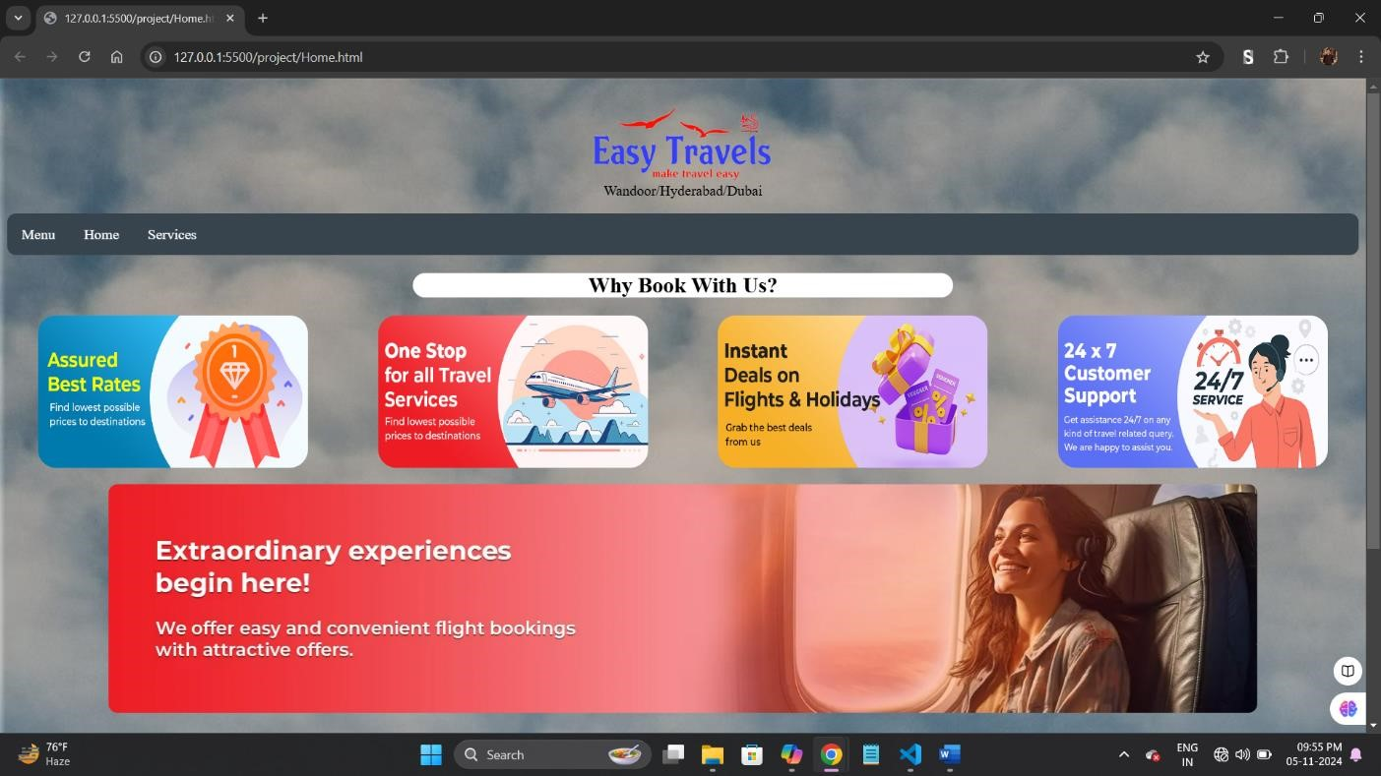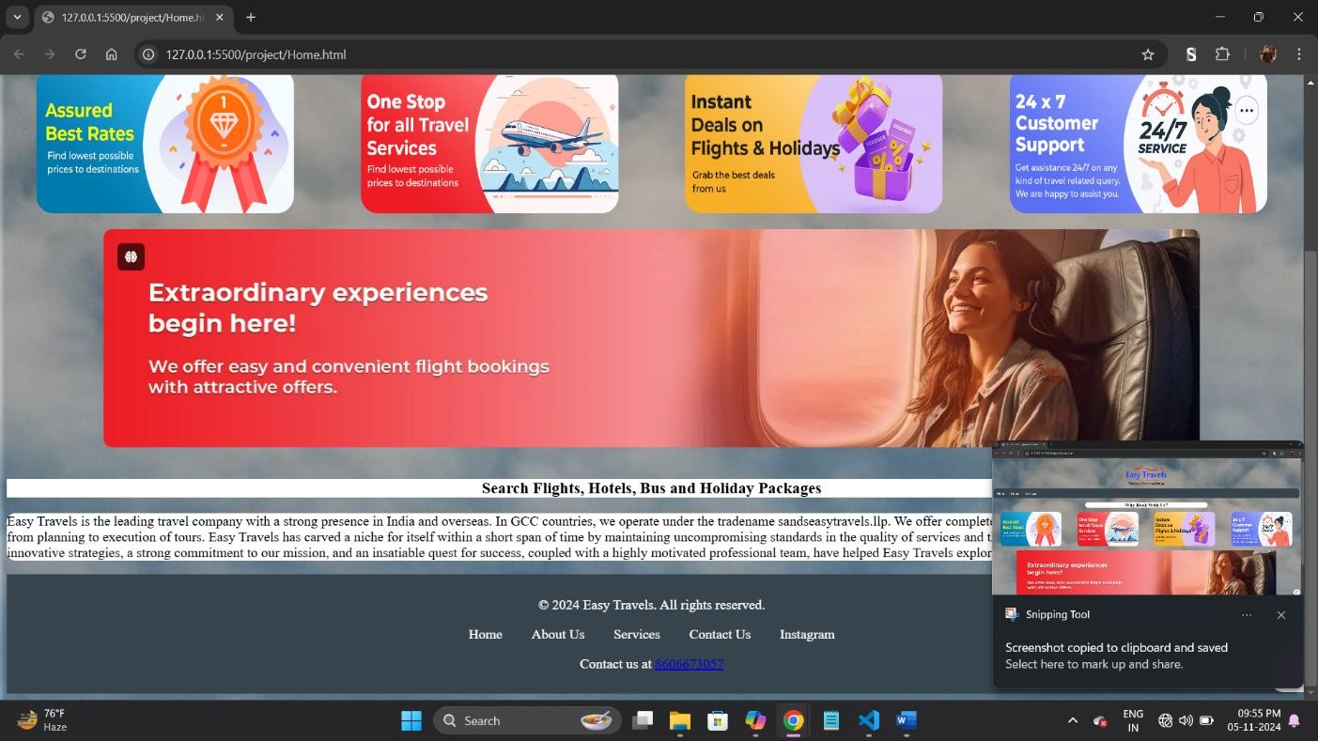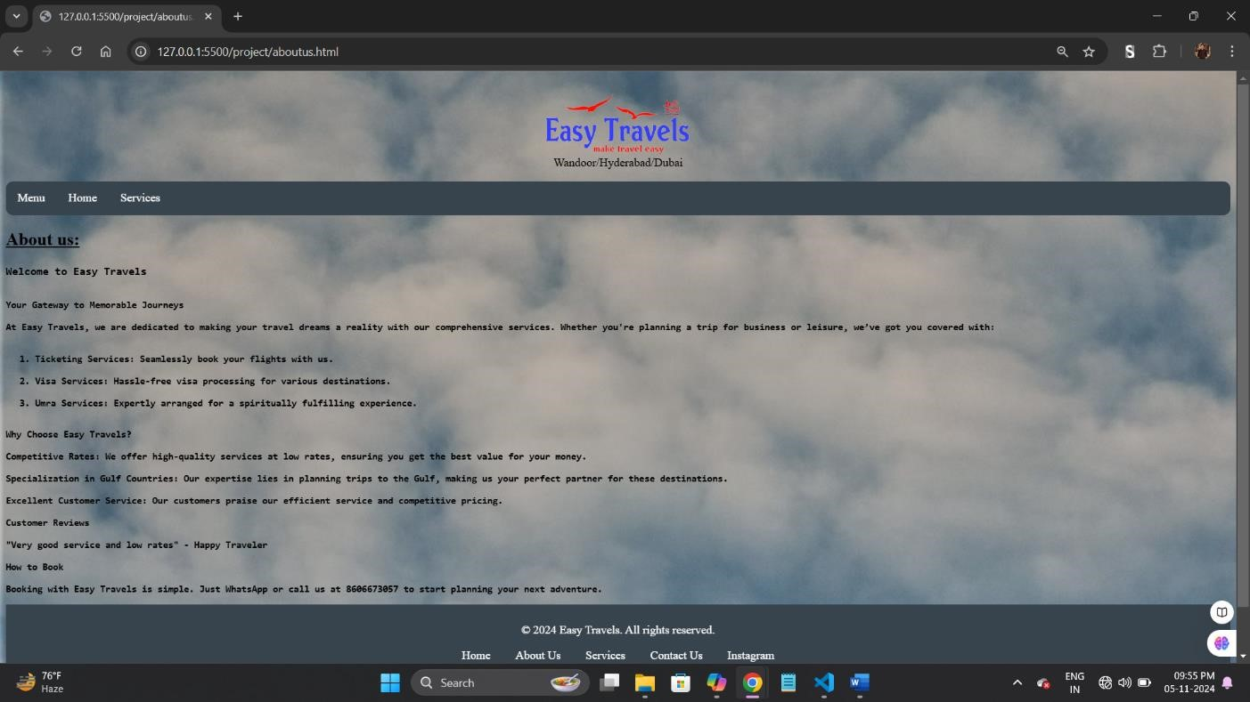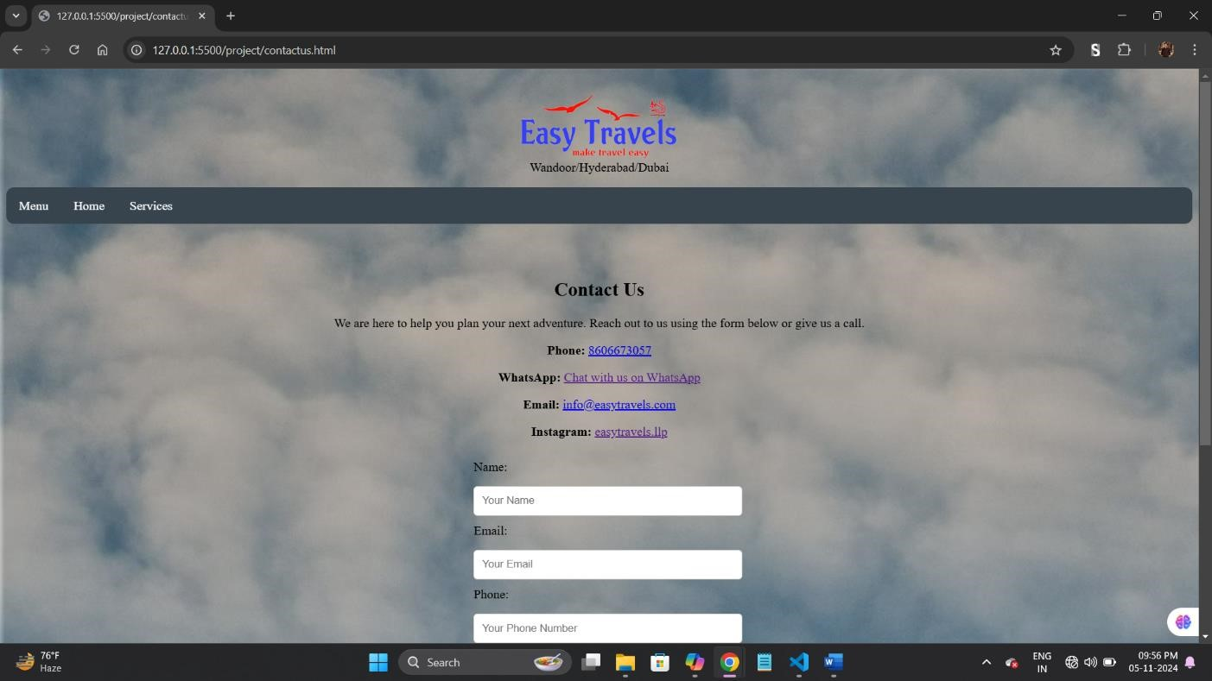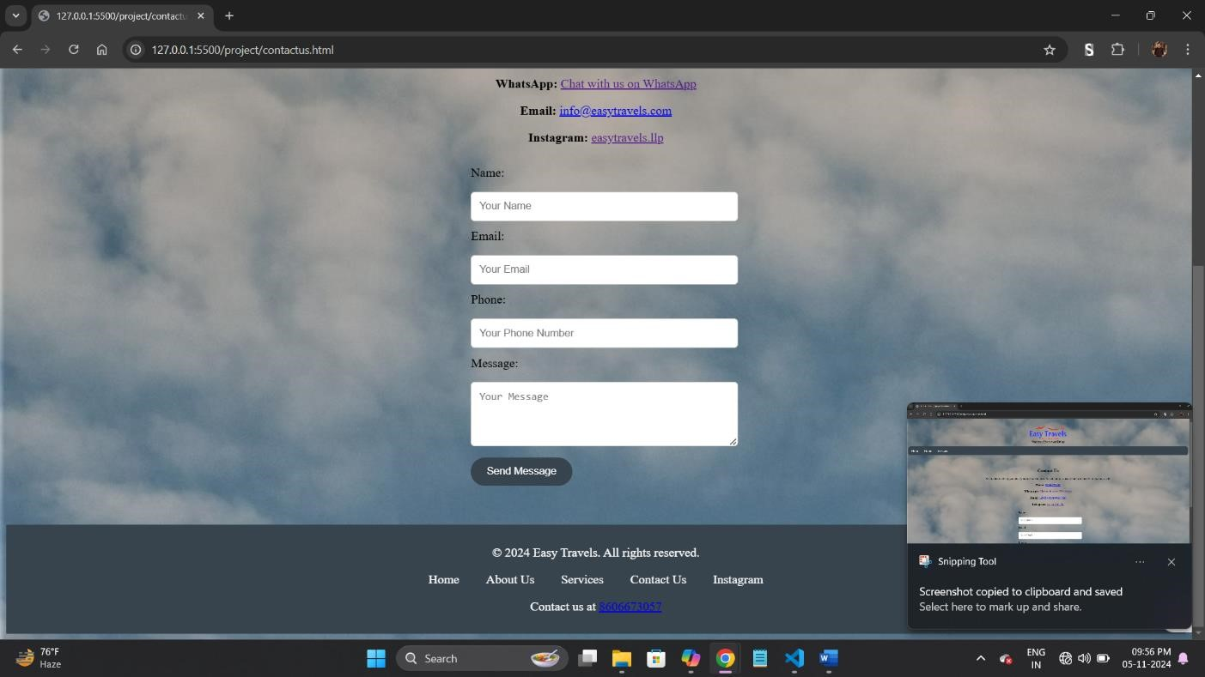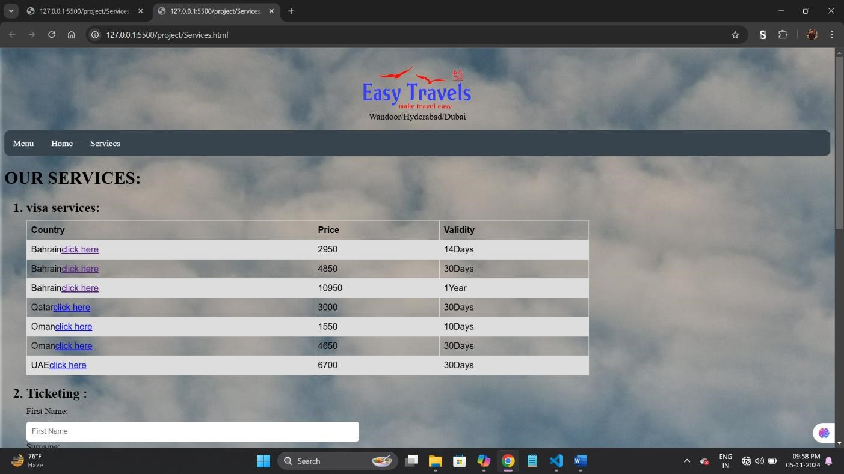

Output screenshots

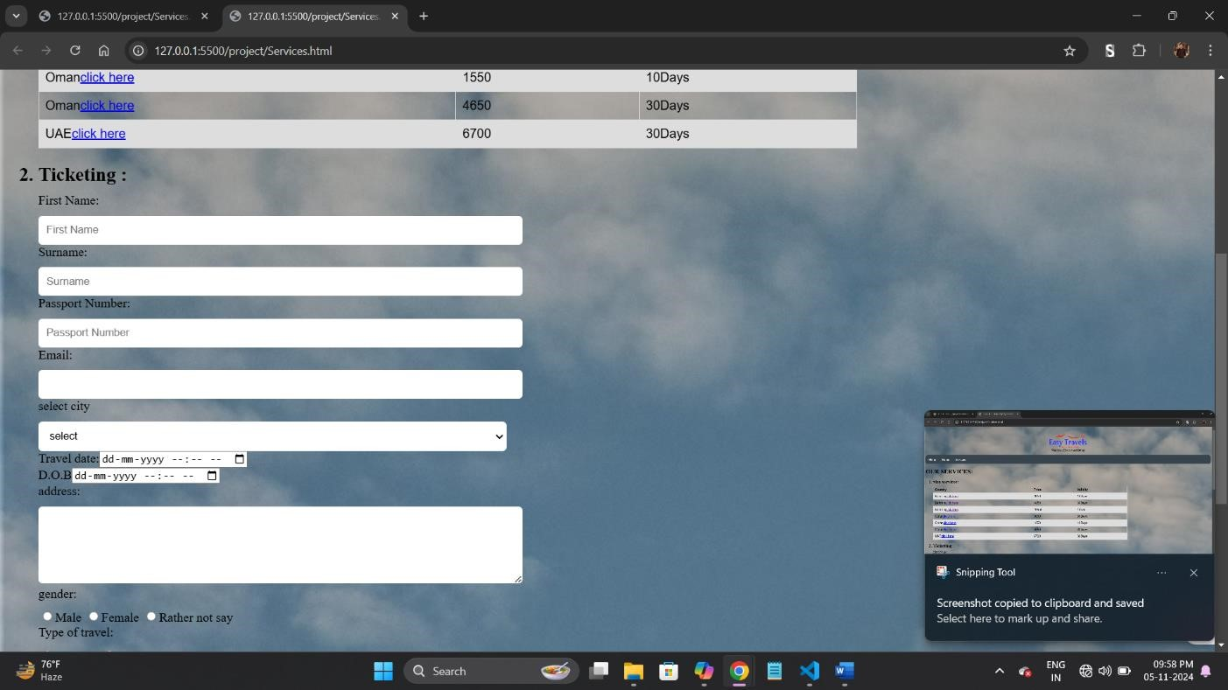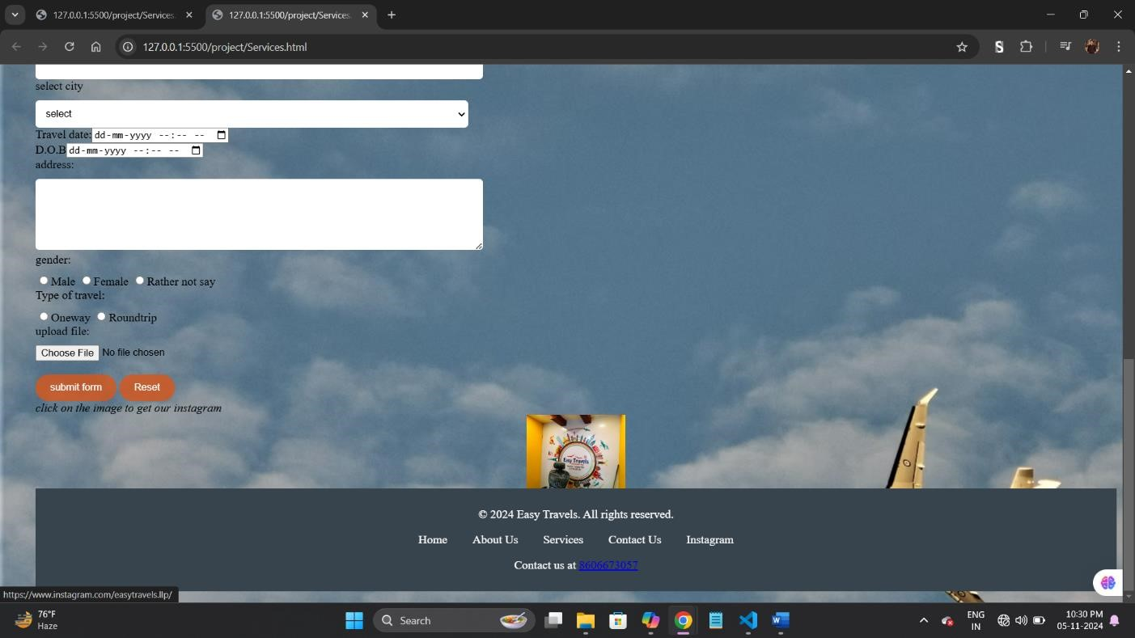

Conclusion:

This travel booking website offers a user-friendly experience, providing a streamlined way for travelers to explore available services, learn about the booking process, and make inquiries. Through effective use of HTML and CSS, we’ve crafted a welcoming and informative platform that encourages seamless travel planning.

References:

1. <https://www.w3schools.com/>
2. Copilot
3. https://www.youtube.com/